Marina Milad  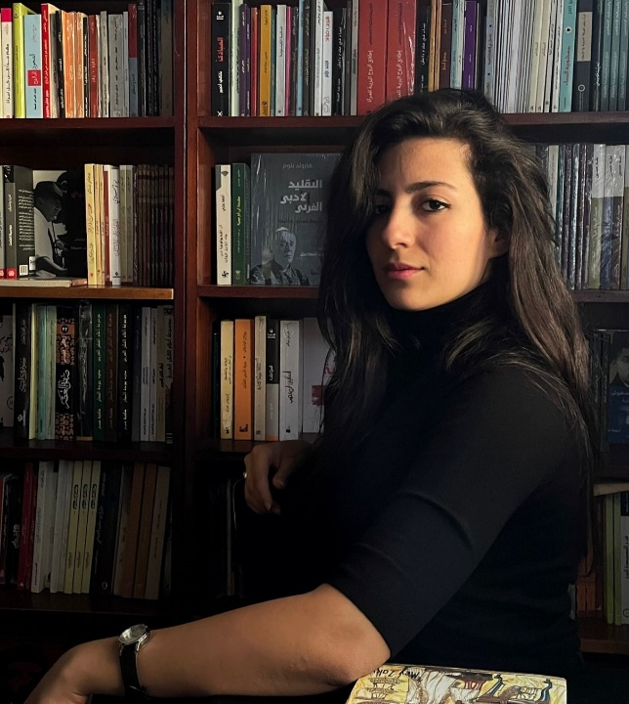  SHORT BIO  A digital journalist and lecturer.  Founder of "Story Time", startup company for producing Media Content and training.  Started working in 2013, began at El-Masry EL-Youm and Rose el-Youssef then moved to digital Media. She worked for Dot Masr website and El-Tahrir newspaper before working at Masrawy website as a digital journalist, also she works as a “one-man crew”.  She works as a freelance video journalist for Deutsche Welle (DW) and collaborated with the Associated Press (AP).  She is a lecturer at The British University in Egypt (BUE), Faculty of Mass Communication - Cairo University and Ahram Canadian University.  She received Heikal Award for the Arabic journalism-2018 and International center for Journalists Award 2023. She was nominated for the Arab Journalism Award 2021, European union Award 2022/2024 and True story international Award 2023.  She made a digital storytelling guide (2 parts) and presented lectures at the American University in Cairo, Faculty of mass communication - Cairo University, Egypt's Journalists Syndicate and other foundations.  She got a postgraduate certificate from the University of Central Lancashire (UCLAN) about Journalism Innovation and Leadership. | 8 Geziret El Arab St. Elmohandseen  Giza, Egypt  (+2) 01276001998  mrnmelad@gmail.com  http://marinamilad.com/
EXPERIENCE  Digital journalist, cross-media stories producer, at Masrawy website since October 2017.  Lecturer at The British University in Egypt (BUE), Faculty of mass communication, Cairo University and Al-Ahram Canadian University for English and Arabic departments.  Founder &CEO “Story Time” Company for Media Content Production & Training.  Freelance video journalist with Deutsche Welle (DW).  Trainer in digital storytelling with some foundations )American University, DW academy, WAIFRA association, etc).  Freelance video journalist with The Associated Press (AP), 2017.  News editor at “El-Tahrir” newspaper, January 2016.  News editor, foreign affairs editor at “Dotmsr” website, January 2015.  Reporter at ONA agency (News Agency of “On TV” channel), May 2014.  Planner at Radio (90.90 FM), March 2014.  Editor at Rose Al-Youssef newspaper, September 2013.  Trainee at El-Masry El-Youm, October 2013.  Cooperated with Global Investigative Journalism Network (GIJN), International Journalists' Network (IJNet), and El-Quds Al-Arabi newspaper through writing articles.  Mentor of “Lebanon Social Impact Reporting Initiative” – The program launched by WAN-IFRA foundation (The World Association of Newspapers and News Publishers).  EDUCATION  - Graduated from Faculty of mass communication, Cairo University, Department of Journalism, (2012-2016).  - Completed postgraduate certificate at the University of Central Lancashire (UCLAN) about Journalism Innovation and Leadership  Trainings  - Got a scholarship for the Netherlands Organization for International Cooperation in Higher Education Orange Knowledge Program for Digital Media Creation course in the Netherlands.  - Completed WAN IFRA Media Management Certificate at the American University in Cairo.  - Got a Fellowship on "The Impact of Conflicts and War on Media and Journalism" organized by the Free Press Foundation (FPU) in collaboration with Maharat Foundation, 2024  - Completed Media Management Certificate at the American University in Cairo.  - Mobile journalism programme (Mojo fest challenge) with Thomson Reuters and was one of top five finalists.  - Got a Grant in Paris in 2019 to produce one story – “Bassem Sabry fellowship” Sponsored by the Embassy of France in Cairo and the French institute.  - Participated in “Caring for Vulnerable Children in a Fractured World” reporting workshop in Nairobi, Kenya, organized by Thomson Reuters.  - Participated in a study tour in Australian newspapers, official TV, and Austrian Agency (APA).  - Completed program about investigations with "ARIJ" in Amman – Jordan, 2017.  - Attended many workshops about data journalism, video journalism, and others at Goethe (Cultural German institute).  - Completed the Reuters Training Course: Introduction to Digital Journalism. 2022  Awards  - Heikal award for Arabic journalism – 2018.  - International Center for Journalists Award 2023  - Nominated for several awards, such as the Arab Journalism Award 2021 and Tandem Media awards (European union awards) 2022/2024 and True story international Award 2023  Stories  My website: http://marinamilad.com/ | SKILLS  - Specialist in digital journalism and storytelling.  - Working as “one-man crew”: writing, shooting videos, photos, In addition to editing (premiere).  - Experience in social media, and digital strategies.  - Good relationships with many sources in different fields.  - Arabic: Fluent (Mother language).  - English: (Very Good at writing, speaking, and ability to communicate in a professional environment).  - Experience in organizing events like “Conference of Government Excellence 2018”, between Egypt and The United Arab Emirates, and the first conference of data journalism in Egypt, March 2018.  - Reasonable knowledge about Photoshop and after effect.

